How to get an SVN client up and running on your machine… and a short Eclipse tutorial

Nikolas Wolfe, Repository Manager
CEN 3031, Summer 2008
(Damn right I’m logging these hours)

At the END of this tutorial…

- you will know how to write and run Java programs in Eclipse
- you will have an SVN client (Subclipse or Tortoise SVN)
- you will have the JAtlantik project built on your local machine

This does NOT explain how to do commits or merging. I will save that for a later document.

Purpose: We’re using a version control system for this project because it’s a large body of code that we will all be simultaneously working on. Versioning software preserves a single atomic copy of the project code and resolves conflicts caused by multiple people working on the same code at the same time.

Google project hosting gives us access to a free repository server where we can store our code, update our local copies, and commit changes as we continue to work on it throughout the semester.

OUR PROJECT REPOSITORY WEBSITE: http://code.google.com/p/cen3031-monopoly/

Note: You NEED a Google account to access the code! Send me (nikwolfe7@gmail.com) your Gmail addresses so that I can add you as project members. If you gave me your address already then you should be able to log in.

This repository uses an open-source version control system called Subversion (SVN). Read about it here if you want: http://subversion.tigris.org/

GETTING AN SVN CLIENT ON YOUR MACHINE
There are TWO ways that I will explain how to do this:
- By directing you to Google’s Subversion tutorial for Tortoise SVN

- Step-by-step how to install Eclipse and the Subclipse Subversion Plug-in
Step 1: Getting Eclipse on your machine
Step 2: Setting up your workspace
Step 3: Creating and running Java projects
Step 4: Getting the Subclipse SVN Client
Step 5: Checking out JAtlantik
1.) Using Google’s Tortoise SVN tutorial (Skip this if you’re going to use Eclipse)
There’s links to a bunch of SVN clients here as well. Use whatever you feel fits your Java developing environment best. (Note: SKIP the section on “Creating a New Project”, as we already have one.
Here: http://code.google.com/apis/gadgets/docs/tools.html#Host
When you reach the point where you need to put in a URL for the SVN repository, use this address:

SVN URL: https://cen3031-monopoly.googlecode.com/svn/

Note: You MUST use https:// as opposed to http:// for a SECURE transfer!

2.) Using Eclipse and the Subclipse Plug-In (Cool people do this!)

Step 1: Get Eclipse on your machine if you don’t have it! (Skip to Step 4 on Page 8 if you do)
Go to http://www.eclipse.org/downloads/, select “Eclipse Classic 3.3.2”, and an appropriate mirror site. Download, extract, and install. You know the drill.

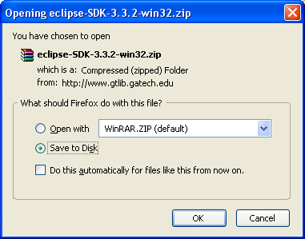

Step 2: Set up your workspace
After you install, when you first start Eclipse you’ll see this window:

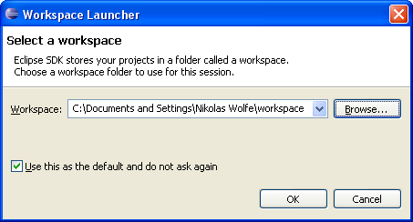

I recommend you use the default workspace they assign you and then check not to ask you again. If you need individual Java files created in an Eclipse project down the road, it is easy to go to \..\workspace\<project name>\src and copy and paste.

Step 3: Create a Java project and run it
Creating and running Java programs in Eclipse is easy. When you first open up the workspace you should see your “Package Explorer” on the left. All projects in your workspace are shown here and you can navigate through the project hierarchy.

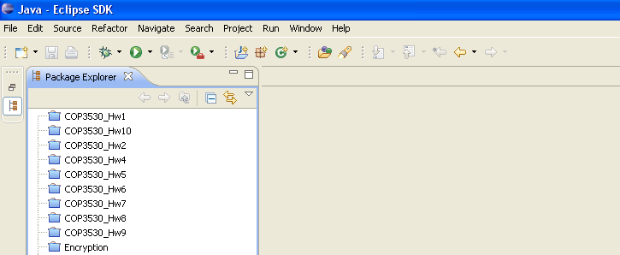

If you’re new, you won’t have any projects here, of course. To CREATE a new project:

A.) Right click in the Package Explorer. Go to “New”, then “Project…” The keyboard shortcut is Alt+Shift+N, and then select “Project…”

B.) You’ll then see the New Project Wizard:

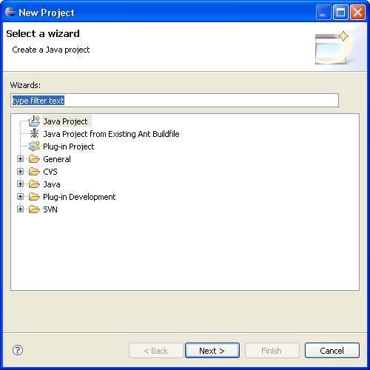

Just press “Next” here…
C.) You’ll then see this window. Just give it a name and press “Finish.”

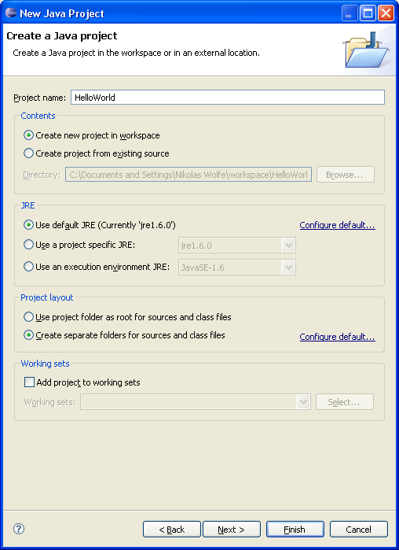

…And you’re done! You should see a new folder in the Package Explorer now with the name you gave it.

D.) This may seem like overkill for just a simple Java program. But, Eclipse is intended for projects of all sizes. Having a package viewer like this is very convenient when you have, say, 30 class files, or anything as big as the thing we’re going to be building.

To create a class: Right click on the project folder, go to “New”, then “Class”. You’ll see the following window:
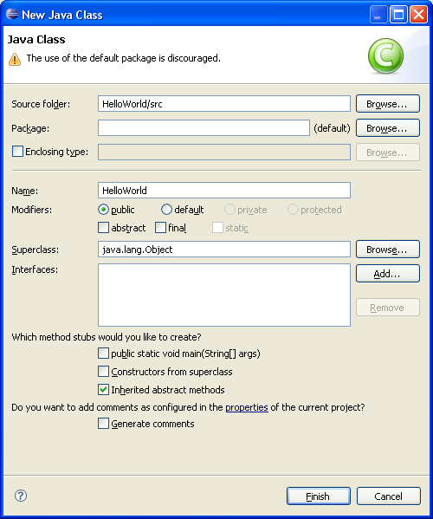

In the “Name:” field, type the class name for your Java file. Disregard the warning at the top and press “Finish.”

E.) Put in some “HelloWorld” junk in the code editor:

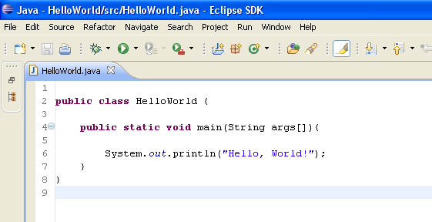
F.) Then, to run the program… First, right click in the code editor or on the folder in the Package Explorer and select “Run As…” and select “Java Application”.

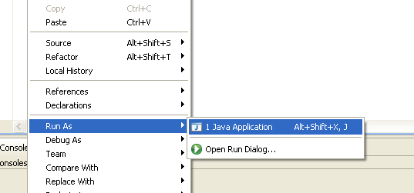

Then, click the green arrow in the toolbar

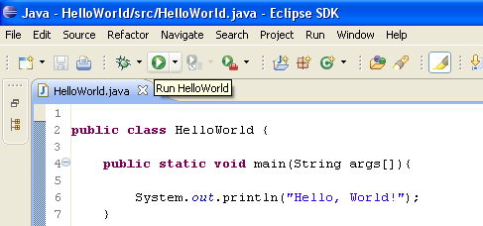

Your console should pop up with the following:

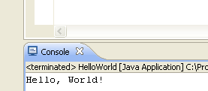

Awesome, huh?! Now you can compile and run programs in Eclipse. Moving on…

Step 4: Getting the Subclipse SVN Client!
Fortunately, Eclipse has a built in tool to get plug-ins from the internet. Unfortunately, there’s two plug-ins required. Here’s how you get them…

A.) Go to “Help”, select “Software Updates”, and then “Find and Install…”

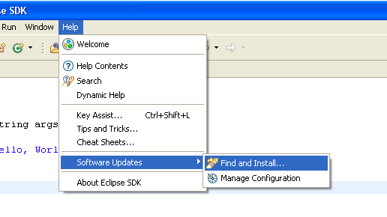
B.) Then select “Search for new features to install” and push “Next”

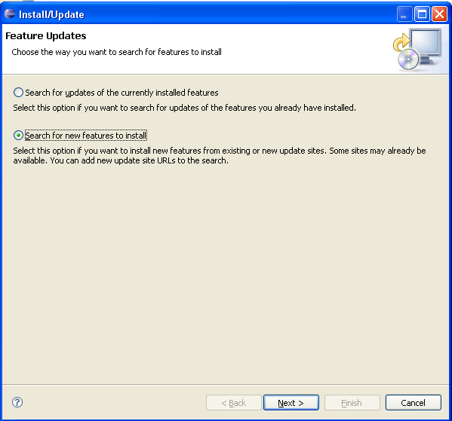

C.) In the next window you want to click on “New Remote Site”, and a small Window will open.

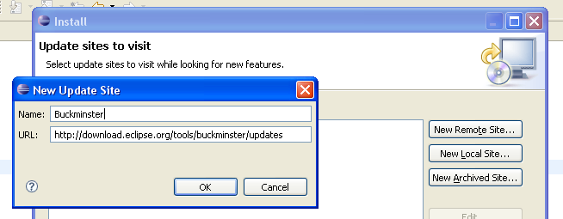

The first update you need is “Buckminster”… Enter the following information in the box:

Name: Buckminster
URL: http://download.eclipse.org/tools/buckminster/updates

The next update is for Subclipse itself. Click “New Remote Site” again, and enter the following:

Name: Subclipse 1.2.x (Eclipse 3.2+)
URL: http://subclipse.tigris.org/update_1.2.x

After you enter this information, you should see the new remote sites in the window. Click “Finish.”

D.) Then you’ll get a mirror select window. Pick one you like, push “OK”.

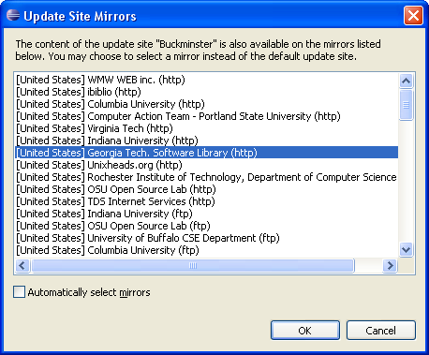

E.) After it searches, you should see a screen similar to the following:

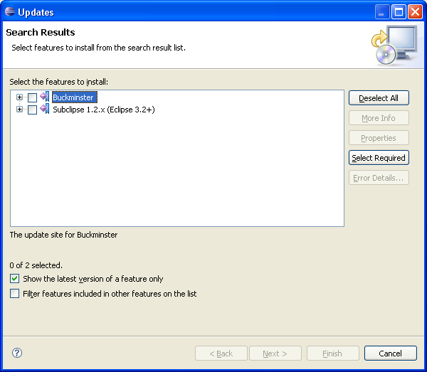

This part can be slightly tricky. Expand all of the items and you’ll notice that there are a lot of options to select. YOU DO NOT WANT TO SELECT ALL OF THESE! There is another Eclipse Plug-in called “Subversive”, which also requires Buckminster to work.

“Subclipse” and “Subversive” are considered MUTUALLY EXCLUSIVE!
ONLY select options for “Subclipse”!

Select the highest check box in the hierarchy, which will highlight all of the items. An “Error” flag should pop up. Then, do the following:

- UNCHECK the option for Buckminster support for “Subversive support”.
- UNCHECK the option in Subclipse for “Subclipse Integration for Mylyn”.

Note: If you continue to see the “Error” flag, try to uncheck the options for things OTHER than “Subclipse” until the flag disappears.

Click “Next”.
F.) As I already have these components installed on my machine, I have to steal these screenshots from the Subversion installation tutorial at http://subclipse.tigris.org/install.html

The next page you see should be similar to this. Accept the terms and push “Next”.

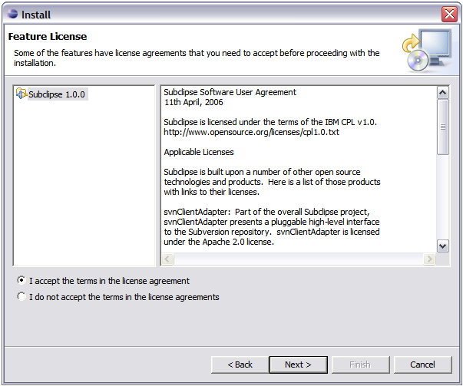

G.) Then you’re going to see something similar to this screen. Click “Finish”.

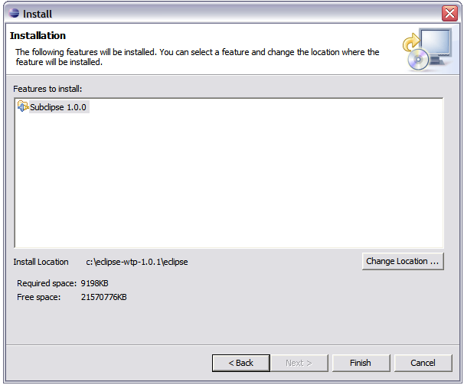
H.) The next screen will likely ask you for a “Feature Verification”. Click “Install All”.

I.) You’ll then see a Load Screen. Load Screens are good.

J.) Then you’ll see a restart prompt like this:

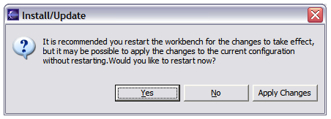

“Yes.” You’d like to restart.

K.) After restarting Eclipse, go to “Window”, and then go to “Open Perspective”, and then “Other…”

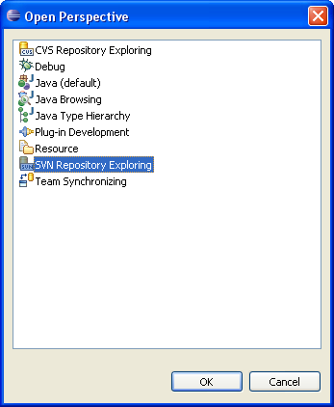

You should see this screen. Select “SVN Repository Exploring” and click “OK”. The windowing should change to your SVN Repository Exploring view. Congratulations you have installed your SVN client!

Step 5 Checking Out JAtlantik
The project code is already in SVN. All you have to do is check it out…

A.) In your SVN Explorer view, right click in the window and click on “Repository Location…”

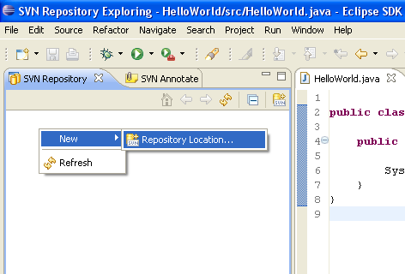

When “Add SVN Repository” window opens up, enter the following URL:

SVN URL: https://cen3031-monopoly.googlecode.com/svn/

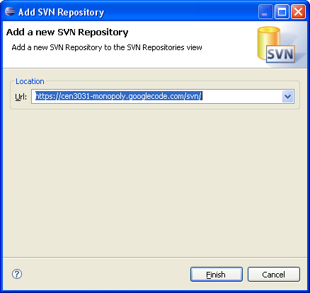
Click “Finish”.
B.) After the repository loads, you should be able to navigate through the directory to this point:

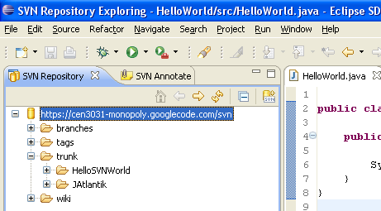

C.) Go from <Repository URL> >trunk > JAtlantic. Then, right click on “JAtlantic”, and click on “Checkout…”

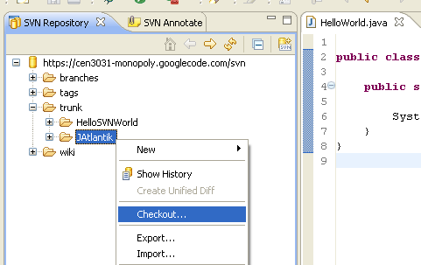

Note: I recommend checking out the “HelloSVNWorld” application too, just to get used to doing checkouts. If you want to look around online about merging and commits, that’s cool, but I’m going to save that for a later tutorial.
D.) You should then see the following window:

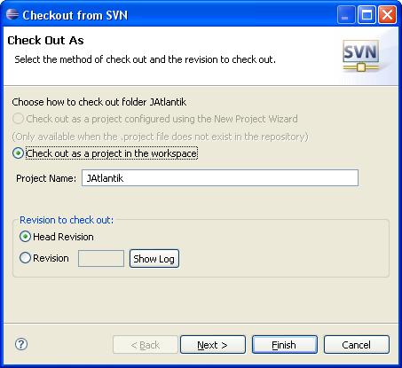

Leave the defaults, and push “Finish”.

E.) When this checks out it will likely prompt you for your username and password. Your username is your Google account username, and the password is on the Google code hosting site.

When you navigate to the project website (http://code.google.com/p/cen3031-monopoly/), click on “Profile” in the upper right-hand corner. Then click on the “Settings” tab. The password is there. If you can’t see the password or can’t access it for some reason, email me.

DO NOT REGENERATE THE PASSWORD!

F.) After it finishes downloading, Eclipse will build the project in the workspace for you. Cool huh? Go to the Package Explorer, and you should see a project by the name of JAtlantik. It should look like this, somewhat:

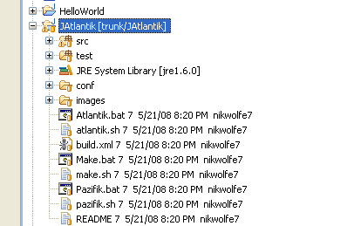

Wow, Congratulations! You now have the entire source code for the JAtlantik monopoly game in your workspace.

Good job!

I’ll put another set of directions up here for doing commits and merging, as that’s a whole different animal.

The end.

